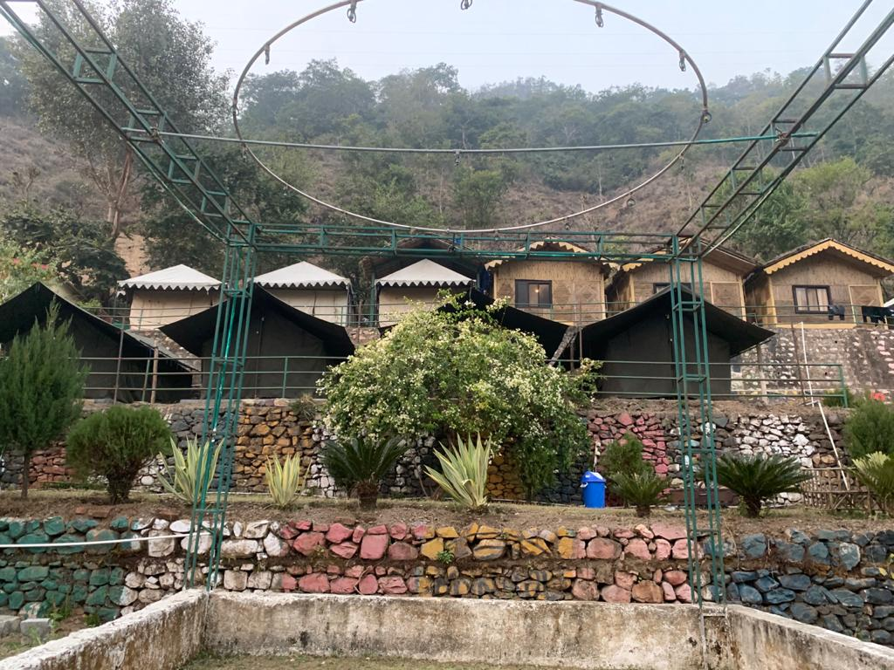
Detailed Itinerary
Friday: Day 01: Arrival Delhi Metro station
Meet at Delhi night 10:00 Pm drive start for your adventure life overnight drive.
Saturday: Day 01: Arrival Shivpuri (Rishikesh) (250 Kms / 5 – 6 Hrs) 409Mtrs
Arrival Shivpuri (Rishikesh). En-route visits Har Ki Pauri (Haridwar) for 01 Hour. Later drive for camp. Check inn into camp on arrival at Shivpuri. Allocation of tent’s by camp manager. Enjoy the hot breakfast & rest after rest Have hot Lunch in camp. After Lunch relax or you can go for “Ganges trekking near" the forest (at your own) Return back to campsite. Evening is free to enjoy games like Volleyball, Badminton & Cricket at Campsite. After darkness 07.00 PM enjoy Bonfire and veg. snacks and share your experience of the day with others. Dinner will be ready at 9:00 pm. Have dinner and overnight camps stay.(Early Check in as per availability.)

Rishikesh: Named after the Lord Vishnu, Rishikesh is a holy city for Hindus. Located in the foothills of the Himalaya in northern India it is also known as the yoga center of the world and is home to many world renowned ashrams. Rishikesh styles itself as the ‘Yoga Capital of the World’, with masses of ashrams and all kinds of yoga and meditation classes. The fast-flowing Ganges is surrounded by forested hills inside the city. Apart from temples and ashrams Rishikesh is now a popular white-water rafting centre, backpacker hang-out, and gateway to treks in the Himalaya.
Sunday: Day 02: Shivpuri (Rishikesh) – Delhi (250 Kms / 5 – 6 Hrs)

Morning After breakfast start rafting in which you will hit some enjoyable rapids like Welcome Shivpuri, Return to Sender, Roller Coaster, Golf Course, Initiation, Double Trouble and Hilton.
Your Rafting guide will brief you about all commands and safety tricks. Enjoy cliff Jumping and Body Surfing on the way. Rafting session will end at – Rishikesh. Explore Rishikesh sightseeing later drive back to Delhi. Drop at Delhi before 10:00 P.M.

 Tour end with sweet memories.

Per Person Package Cost: INR 3800/- Per Person (till 31 March 2021)

Note: Above rate is not valid on long weekend, New Year or festive weekend.
Camp Details
Destination | Deluxe | Camp Type | Night
Shivpuri (Rishikesh) | Cradle Of Life or Similar | Swiss Camp | 01

Meal Plan will be same or Similar:
The meals will be served on buffet style (Vegetarian & Non-Vegetarian) as per the schedule.
- Breakfast (8:30 Am to 10:00 Am): Bread /Butter/Jam/Poha or Upma/ Egg Bhurji or Boiled Egg / Puri Bhaji or Chole Bhatura or Stuffed Parantha / Tea
- Lunch (1:00 pm to 2:30 Pm): Achar/Salad/ Roti /Seasonal Veg / Dal / Rice / Kofta Curry or Achari Aloo or Dum Aloo/Raita
- Eve. Snacks (6:00 Pm to 7:00 Pm): Papad/ Chips/ Aloo Chat / Pakora.
- Dinner (9:00 Pm to 10:30 Pm): Achar/Salad/ Roti or Nan / Dal /Rice / Seasonal Veg / Paneer Dish / Chicken Dish / Dessert ​

Cost includes:
- Camp accommodation as per package same or similar Camps.
- Meals as per package (02 Breakfast + 02 Lunch + 01 Evening Snacks + 01 Dinner).
- 01 Time River rafting during the stay (Shivpuri to Rishikesh).
- Evening light Music with Snacks and bonfire.
- Free use of Indoor Camp games, Beach volley ball, Cricket & Badminton.
- Transfers and sightseeing as prepackage car.
- All toll tax, parking, fuel and driver allowances.
- All applicable hotel and transport taxes.

Cost doesn’t include:
- 5% GST will be extra on bill.
- Others meals does not include in Package.
- Anything not mentioned under ‘Package Inclusions’
- All personal expenses, optional tours and extra meals.
- Medical and travel insurance.
- Any kind of entry fees anywhere if not mentioned in including.
- Tips, travel insurance, medical insurance, laundry charges, liquors, mineral water, telephone charges.
- All items of personal nature.
- Porter, pony, horse, cable car, boat, train tickets, air tickets charges.

Payment:
- 40 % advance and balance at the time of trip start.
- We required full advance for Helicopter ticket confirmation.

Refund:
- 30 Days before full Refund
- 15 Days before no refund.
- Helicopter cancelation as per helicopter policy.

Policy (Adventure Activities & Camping)

- It is not advisable to join for rafting if you are under any medical treatment (like Diabetic, Fit, high & low B.P., vertigo, Asthmatics, Heart problem, any surgery & tribal will be your own responsibility
- The management is not being responsible for any type of hazard, accident happened inside or outside of camp premises.​
- We do not have any insurance policy covering the expenses for accident ,sickness, loss due to theft or any other reason, guests are advised to seek such insurance arrangements in their home country.
- We shall not be responsible for any delays & alterations in the programmed or expenses incurred- directly or indirectly due to natural hazards, accident, breakdown of machinery, equipment’s, transport, traffic situation ​weather condition, sickness, landslides, political closure or any untoward incidents.
- Numerous factors such as weather, road conditions, the physical ability of participants etc. may dictate itinerary change. We reserve the rights to change any schedule in the interest of safety, comfort & general well being.
- We reserve the rights for the cancel of particular person not following the instructions of our guide during any activity.
- We reserve to rights for cancellation of the person such as alcoholic, misbehaved. Such persons are strictly prohibited.

Term and Conditions​

- All bookings are strictly subject to availability and confirmation by payment of Non-refundable Advance.
- Towels & slipper will not be provided in camp, so you have to carry your own towels & Slippers.
- For quad sharing we have sofa in deluxe tent only, will provide the same, no additional bed.​
- We request not to travel with heavy luggage since have to trek 1​00mtrs till our camp from main road with self service luggage.
- Management shall not take responsibility of missing items from camp or its premises, hence requested not to travel with too much ornaments, jewelry, cash and other etc.
- In case if going out of Camps please deposit valuables in safety locker with the security of our Camp Manager.
- All our packages are ‘group packages’ and same services/items are applicable for each person in the group.
- Total cost will not be affected if there is any reduction in the number of persons and camps.
- Total cost will not affect if climate condition not allow doing rafting.​
- Any meal, activity or service not availed by the client will not be adjusted in the package cost and non-refundable under any circumstances.
- We entertain only those persons at the campsite for whom the booking has been made. No additional persons will be entertained under any circumstances.
- Room Service is not available and guests are requested not to embarrass us by insisting on Room Service or taking meals to the tents.
- Parking will be at owner's risk, we do not have our own parking space.
- You are requested to fairly assess your physical disposition before making the reservations. Camping is not suggested for expecting women, families with infants and those having difficulty in walking moderate distances.
- Please read emails carefully and understand the contents and prices. All the email conversations will be also part of your contract with us once you make the booking.
- Please take care of the belongings before leaving the car or Hotels. Company is not responsible for any loss.
- As per the directive given by the Government of India, all Indian/Foreign Nationals are required to provide proper proof of identification upon check-in. Valid identifications documents are: Passport & Visa together, Voters Id card, Current Drivers License. All the documents must include a photograph.
- Hotel / camps or any kind of accommodation can deny stay if valid id proof is not provided. Company is not responsible for any ID proof related issues.
- For extra adult many hotels provide extra mattress also instead of extra bed. Kindly inform us in advance if you prefer only extra bed instead of extra mattress.
- It is presumed that the tourist is medically fit to undertake the tour. If you have certain kind of allergy (especially for food) or any serious health issues kindly inform us in advance.
- Many small hotels / resorts do not have lift so kindly inform us in advance if you are not comfortable with stairs.
- Generally hotel check in time is 14:00 hrs and checkout time is 11:00 hrs across India. Confirm early check in or late checkout will be chargeable if not included in cost. Kindly contact hotel directly if you want complimentary early check in or late check out.
- Many hotels charge extra for room heater or wifi. Normal package does not include this so in that case these charges should be paid at hotels.
- If meals are included in package it will be served at set menu basis in a buffet menu / fixed / meal credit. Any items which are not in their in ideal Buffet / Fixed menu will be charged extra at the time of consumption. Hotels decide the menu and options of items for menu. Some hotels having Meal credit policy instead of Buffet or Fixed Menu during low occupancy in hotel – This meal credit amount is decided by hotel management – if bills goes above the given meal credit amount then extra amount should be paid directly at respective hotel. Room service for the food or packing is charged extra at many hotels.
- Due to any reason if Vehicle breakdown due to technical reasons we will try our best to arrange another vehicle as soon as possible for the major problems. For minor problems which will not take much time vehicle will be repaired. Kindly cooperate.
- We shall not be responsible for any delays & alterations in the program or expenses incurred directly or indirectly due to natural hazards, flight cancellations, accident, breakdown of transport, weather, sickness, landslides, closures/blockades due to political unrest or any such incidents.
- AC will not work in all hill areas or stopped / parked vehicle.
- Driver will not drive on No-entry zones and should not be forced to drive on narrow streets or roads which can create traffic jam. Normal working hours of driver is 12 hrs in case you want services more than 12 hours in a day kindly inform us in advance.
- In some hill area roads driving after sunset and music is not allowed due to risk of life. Kindly cooperate for the same.
- Pick up and drop point will be one only (If multiple pickups and drop please mentions email conversation before booking)
- In case you want multiple visit to the some particular place kindly mention in advance because some places are having very high charges of parking.
- Tour destination / route cannot change without prior notice (Amended route and tour Destination rates may be change)
- The rates are subject to change, depending on the fluctuation of diesel/Petrol prices in India. If the prices increased more than 5 % than the time of booking we will increase the rate even if the rates are confirmed earlier.
- India easy Trip Pvt Ltd. reserves the right to give you a similar car if the car you booked is unavailable.
- At many of the tourist destination / hill station - some of the road / shopping market / mall road have "NO ENTRY" for all / some bigger tourist vehicles depends on destination along with time restrictions also. In this kind of situation guest have to manage another available mode of transport with an additional cost and on direct payment basis, this cost is not included in ideal package inclusion.
- Some time vehicle parking area little far from the sightseeing spots. Guests need to reach the parking at their own cost.
- Vehicle will be permitted to use for sightseeing points on the route and inside the city limits or which is mentioned in itinerary. For additional sightseeing, off route sightseeing, sightseeing not inside the city limits or substitute sightseeing kindly contact company. Refund is not possible if any particular sightseeing point is not covered. In case you want some excursions kindly inform company in advance or discuss these things with company rather than driver. All nearby sightseeing points should be covered together. However in case of sometime issues with some particular place we can adjust.
- No refund for short stay or unveiled facilities.
- No cancellation or any refund will be made if situation is beyond our control, such as bad weather, landslide, climatic conditions or any other natural disaster, fire, any embargo, acts or decisions of government, political or national crisis, road blocks, heavy snow fall, acts of terrorism or other similar causes, strikes or problems at airlines, rails, buses, hotels or transporters, labor unrest, insolvency, business exigencies, operational and technical issues, route and flight cancellations or due to which the customer could not reach the destination and which is beyond our control.
- Company is not responsible for any accident/injury/death/theft of person or property during the course of the tour.
- All rights reserved to management to cancel any service without any refund until full advance money towards the service is received from the customer and accepted by company. Company can change the features or functionality of the services at any time, without any notice.
- Company Here by expressly disclaims any implied warranties imputed by the laws of any jurisdictions or country other than India. Company considers itself and intends to the jurisdictions only of the court of Rishikesh Uttarakhand India.

